Matrix operation

1

(2-variable function)

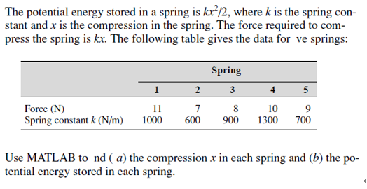

2. Follow the step of the structure plan to do the HW3.7 in p. 90 of the textbook

3. To write the following functions as the anonymous function

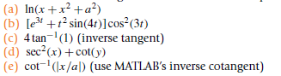

4.

## write following programs as the matlab function

(a)

Temperature conversion from C to F or F to C as requested by the user

Dec = input(' Which way?: 1 => C to F? 0 => F to C: ');  
Temp = input(' What is the temperature you want to convert? ');  
%  
% Note the logical equals sgn (==)  
if Dec == 1  
 TF = (9/5)*Temp + 32;  
 disp(' Temperature in F: ')  
 disp(TF)  
else  
 TC = (5/9)*(Temp-32);  
 disp(' Temperature in C: ')  
 disp(TC)  
end

function newBalance = cal_balance(money,nm,rate);

for k=1:12 %% ¤ë¥÷

money = money *1.01;%%¥»ª÷¥[§Q®§

newBalance(k)=money;%%¨C¤ë¦s´Úµ²ºâ

money=money+50;%%¨C¤ë©w¦s

end

% output

for k=1:length(newBalance )

fprintf('The new balance of the %d month is %4.2f: \n',k,newBalance(k))

end

b.

function newBalance = cal_balance(money,nm,rate);

for k=1:12 %% 月份  
 money = money *1.01;%%本金加利息  
 newBalance(k)=money;%%每月存款結算  
 money=money+50;%%每月定存  
end  
% output  
for k=1:length(newBalance )  
 fprintf('The new balance of the %d month is %4.2f: \n',k,newBalance(k))  
end

%% write this program as the matlab function

% Temperature conversion from C to F

% or F to C as requested by the user

%

Dec = input(' Which way?: 1 => C to F? 0 => F to C: ');

Temp = input(' What is the temperature you want to convert? ');

%

% Note the logical equals sgn (==)

if Dec == 1

TF = (9/5)*Temp + 32;

disp(' Temperature in F: ')

disp(TF)

else

TC = (5/9)*(Temp-32);

disp(' Temperature in C: ')

disp(TC)

end